IoT Nexus MATLAB Learning Journal
  - Motor fundamentals and our first recorded simulation experiment
Session 01 | 17 October 2026 | MATLAB R2026b
This journal explains how our simulated DC motor works and records the first experiment. We apply a fixed voltage, monitor current and speed, and add an opposing shaft load. The goal is to understand the motor before adding automatic speed control.
The first motor experiment has run successfully in desktop MATLAB. Its steady values agree with hand calculations and it passes the numerical checks described later. All motor parameters are teaching assumptions. We have not tested a physical motor or built a fault detector.

What the first experiment shows
Final steady measurement | No external load | Added load
Speed | 2604.35 RPM | 2170.31 RPM
Current | 0.2727 A | 0.7273 A
Winding loss | 0.1488 W | 1.0578 W

The voltage stays at 6 V. When the shaft meets extra load, its speed falls and its current rises. A constant voltage therefore does not guarantee constant speed under different loads.

How this journal will be maintained
The ongoing GitHub record is docs/matlab/learning-journal.md. It will retain the question, changes, assumptions, experiments, evidence, lessons and next step for each session. This Word document is the readable snapshot for session 01. Learner reflections remain unanswered until you write them in your own words.
The active plan is simulation first. No hardware purchase is required. The earlier hardware proposal remains a historical document and is not the current shopping plan.

The motor concepts we are rebuilding
A DC motor converts electrical input into rotational motion. The winding carries current, the magnetic field produces a turning effort, and the shaft accelerates. The quantities below describe different parts of that process.
Quantity | Unit | Meaning
Voltage | V | Electrical potential difference across the motor terminals.
Current | A | Electric charge flowing through the motor winding each second.
Torque | N m | Turning effort produced by the motor or opposed by the load.
Speed | RPM or rad/s | How quickly the shaft rotates.
Back EMF | V | Voltage generated by rotation that opposes the applied voltage.
Inertia | kg m² | Resistance to a change in rotational motion.

Why current is high during startup
The stationary shaft generates no back EMF. Applying voltage starts building current in the winding. Inductance prevents an instantaneous jump, but current rises quickly. That current produces torque and starts accelerating the shaft.
As speed rises, back EMF increases. Less voltage remains to drive winding current, so current falls. Eventually motor torque balances friction and the external load. With no external load, some current is still needed to overcome the friction included in our model.

Why a load changes both speed and current
Extra opposing torque initially makes the motor slow down. Lower speed reduces back EMF, which allows more current. More current produces more torque. At the same fixed voltage, the motor settles at a lower speed with a higher current.
Current alone does not identify a fault. A normal increase in mechanical load can raise it too. We need operating context and other measurements before interpreting a warning as a failure.
Speed conversion: 100 radians per second is about 955 RPM. Torque and speed are different: a shaft can experience turning effort even when it is not rotating.

The equations and our assumptions
The model has two changing quantities: winding current i and shaft speed ω. One equation describes the electrical circuit; the other describes rotational motion. Integrator blocks accumulate the rates of change over time.

Electrical balance
$$V = R i + L \frac{di}{dt} + K_{e} ω$$
R i is the resistive voltage drop. The inductive term describes the voltage associated with changing current. Ke ω is back EMF. A motor therefore needs more than the resistor relationship V = R i.

Mechanical balance
$$J \frac{dω}{dt} = K_{t} i − b ω − T_{L}$$
Kt i is motor torque. The terms b ω and TL oppose it through viscous friction and the external load. Any remaining torque changes the shaft speed. Kt and Ke are numerically equal in this ideal conversion model when expressed in the specified SI units.
Assumed motor parameter | Value | Unit
Winding resistance R | 2 | ohm
Winding inductance L | 0.002 | H
Torque constant Kt | 0.02 | N m/A
Back EMF constant Ke | 0.02 | V/(rad/s)
Rotor inertia J | 0.00002 | kg m²
Viscous friction b | 0.00002 | N m/(rad/s)

These are explicit teaching values, not a motor datasheet. The source file lesson01_parameters.m controls them. The numerical solver step is 20 microseconds; recorded samples are spaced by 100 microseconds. Neither value represents a physical encoder or controller sampling rate.

Our first recorded experiment
Both cases start at rest. We apply 6 V at 0.05 s. At 1 s the loaded case receives an opposing torque of 0.01 N m; the baseline receives no external torque. Both main simulations stop at 2 s.
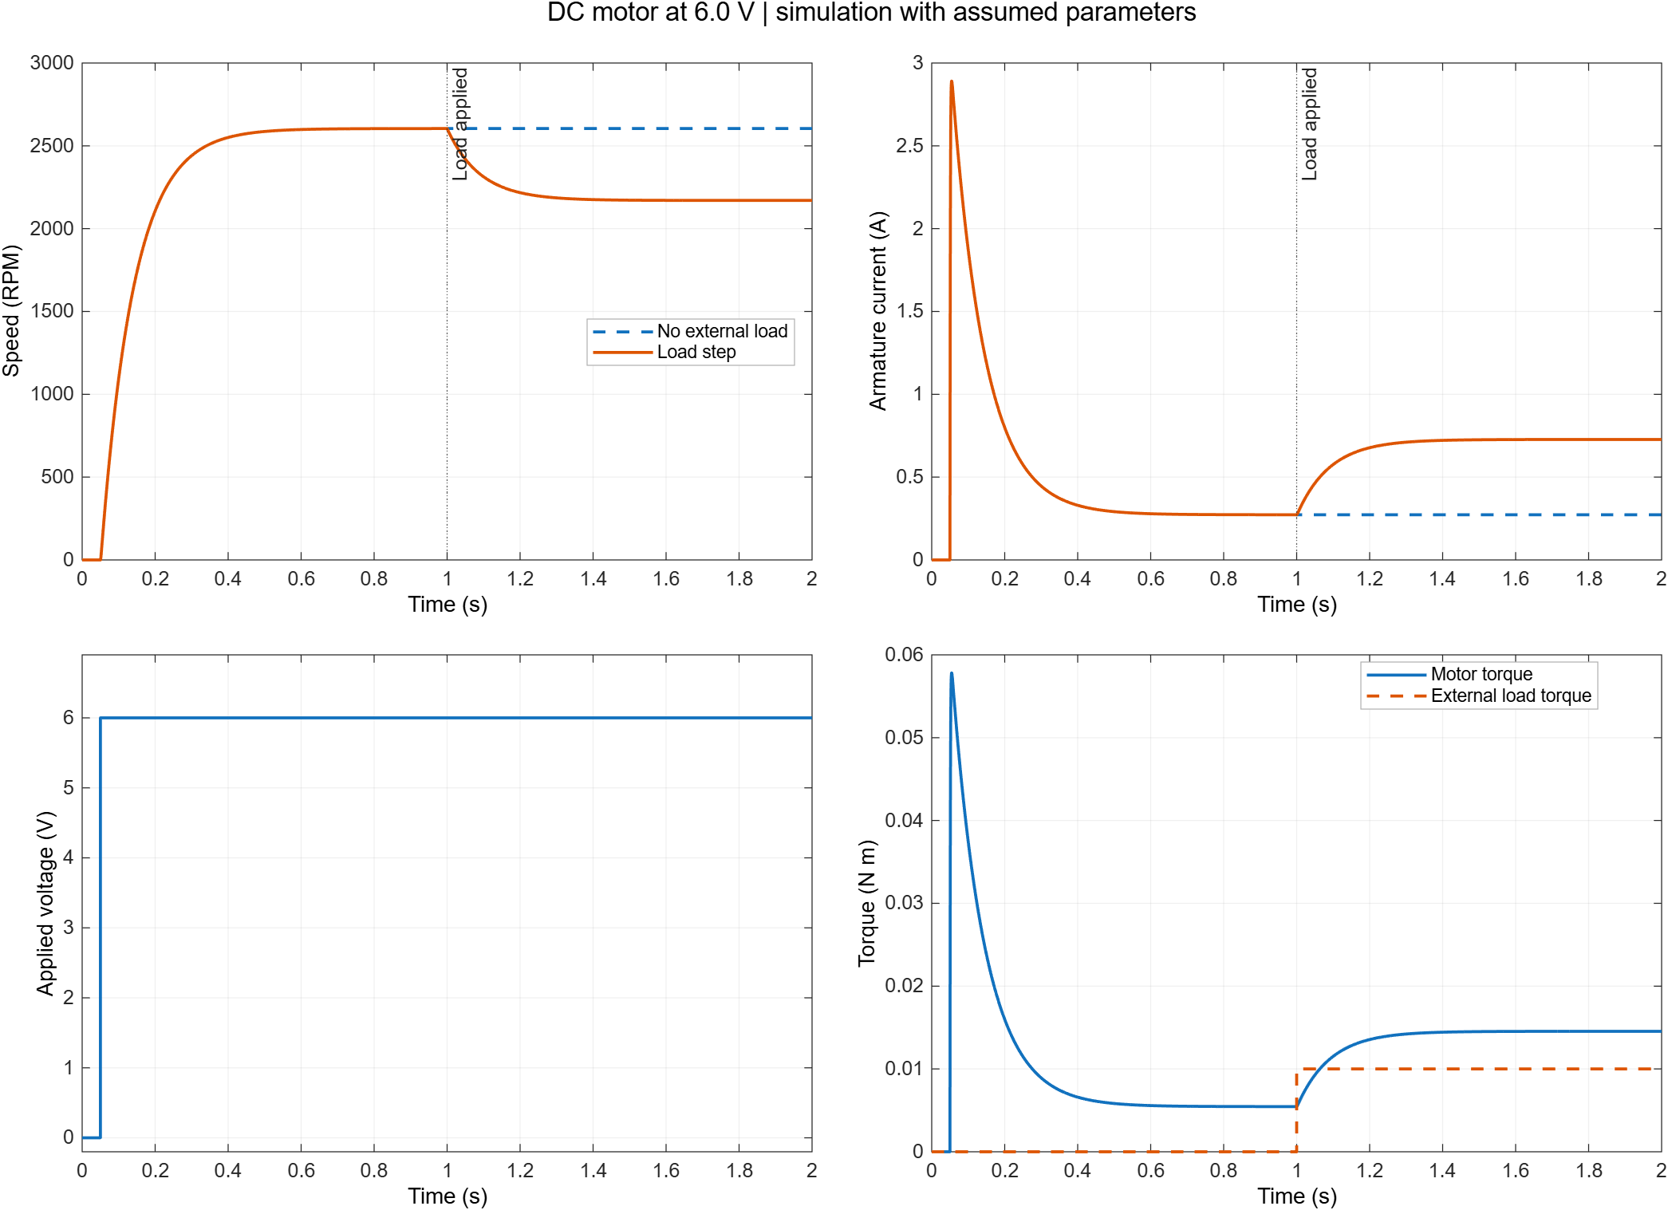
Figure 1 Actual MATLAB outputs from the saved lesson 01 run
Read the voltage plot first, then speed, current and torque. The initial current peak produces acceleration. Current falls as the shaft gains speed. At 1 s, the loaded motor slows and draws more current while the baseline continues at its earlier speed.
The final speed decreases by 16.67 percent. The reported steady values are means over the final 0.1 s, after most of the transient has passed.
Electrical input power is V i. Winding loss is R i². Load power is TL ω. The difference also involves friction and changes in stored energy. Winding loss in watts is not a temperature reading; temperature requires a separate thermal model.

How to run and inspect the model
The model is built from standard Simulink blocks so that we can inspect the individual terms. It uses MATLAB and Simulink. A later comparison will use physical components from Simscape Electrical.
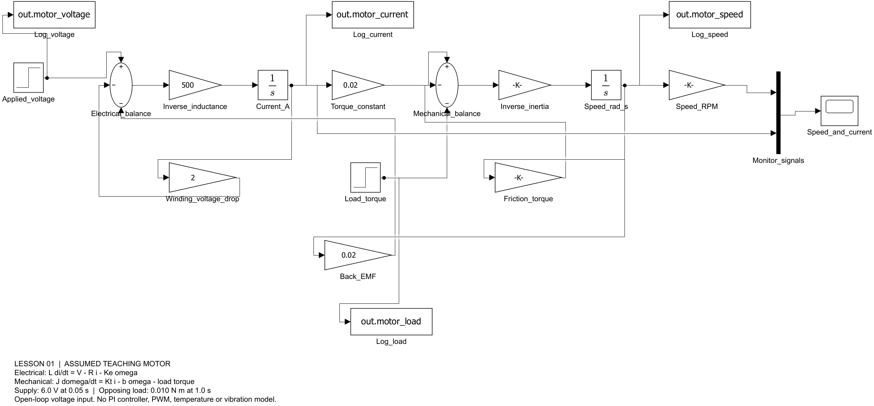
Figure 2 The generated motor model with its physical feedback terms

Run it in your MATLAB window
Paste these two lines in the Command Window. If you move the repository, replace the path with your new simulation folder.
cd('E:\IoT Website\websites\iot-dashboard\simulation\matlab')
runFolder = run_lesson01;
The runner creates a fresh folder, runs both cases and a numerical refinement check, opens the model and result figure, and prints the output location. Existing runs are preserved. Use Save As before making separate edits to a saved model.

What the saved files contain
File | Purpose
nexus_l01_*.slx | Editable model with numeric parameters.
baseline_no_load.csv and load_step.csv | Recorded simulated signals with units in column names.
lesson01_results.png | Comparison plots for inspection and portfolio evidence.
summary.json and RESULTS.md | Parameters, results, analytical comparison and check outcomes.

The full MATLAB workspace recording is retained locally as raw_simulation.mat. CSV, model, plots and summaries are the portable evidence for GitHub. The Nexus website still uses its separate illustrative demo; no import connection has been added yet.

Session record and the next questions

What worked and what we corrected
The earlier built-in vdp example could not be found. We replaced it with a small model created from standard blocks. The learner screenshot confirms that the resulting ramp test ran successfully.
We then built and ran the motor model locally in MATLAB R2026b. An initial 100 microsecond solver step matched the equilibrium calculation but missed the speed refinement threshold: its maximum difference was 0.1951 RPM against a 0.1 RPM limit. We retained that failed check, reduced the step to 20 microseconds, and kept the original tolerance.
The final refinement differences are 0.039017 RPM and 0.00004132 A. All six checks pass: finite signals, two equilibrium comparisons, expected speed and current changes, and numerical refinement. The comparison excludes 20 ms around switching events.
Agreement with our equations checks the implementation and numerical settings. It does not establish that the assumed motor matches real hardware. Temperature, vibration, PWM switching, current limiting, a speed controller and fault detection remain later work.

Your observations to add
- Explain in your own words why the current falls after startup.
- Explain why the extra shaft load raises current while lowering speed.
- Predict the effect of changing the applied voltage to 4 V before trying it. Change one parameter at a time and preserve the new run.

Portfolio and blog material
Keep the question, parameter assumptions, editable model, comparison plot and numerical checks together. A first article can explain what current and speed reveal about a motor before a controller is added. Write personal conclusions after reviewing the results; the journal does not invent learner reflections.
Next we will review these plots together, then compare this equation model with a Simscape Electrical circuit. We will add speed control once the baseline behaviour is understood.

Evidence and references
Recorded folder: lesson01_20261017_221702_944. The exact folder and GitHub links are recorded in docs/matlab/learning-journal.md.
MathWorks DC Motor block https://www.mathworks.com/help/simscape-electrical/ref/dcmotor.html
MathWorks DC Motor Control example https://www.mathworks.com/help/control/ug/dc-motor-control.html

